FAQ: Transcripts and Scores Requests
Submitting your Final Transcript
To request your final transcript, you will need to complete the Senior Year End Activity in SchooLinks. Detailed instructions were emailed. It is also on the CCR website.
Final transcripts will not be available until June. Your transcript will be sent only if you have completed the Senior Year End Activity in SchooLinks. You cannot request your final transcript via email. The Senior Year End Activity must be completed to have your final transcript sent to your school.

Requesting your HCC Transcript
If you are currently enrolled in a dual credit course with HCC, your course does not officially end until May 10th. Please wait to request your transcript until your course is complete and your final grade has been posted.
To request your transcript, use this link. You will need to create an account, enter your information and your college’s information, and pay a $7 fee.
Important: Neither Dr. Williams nor your counselor can send your HCC transcript. You must request it yourself.
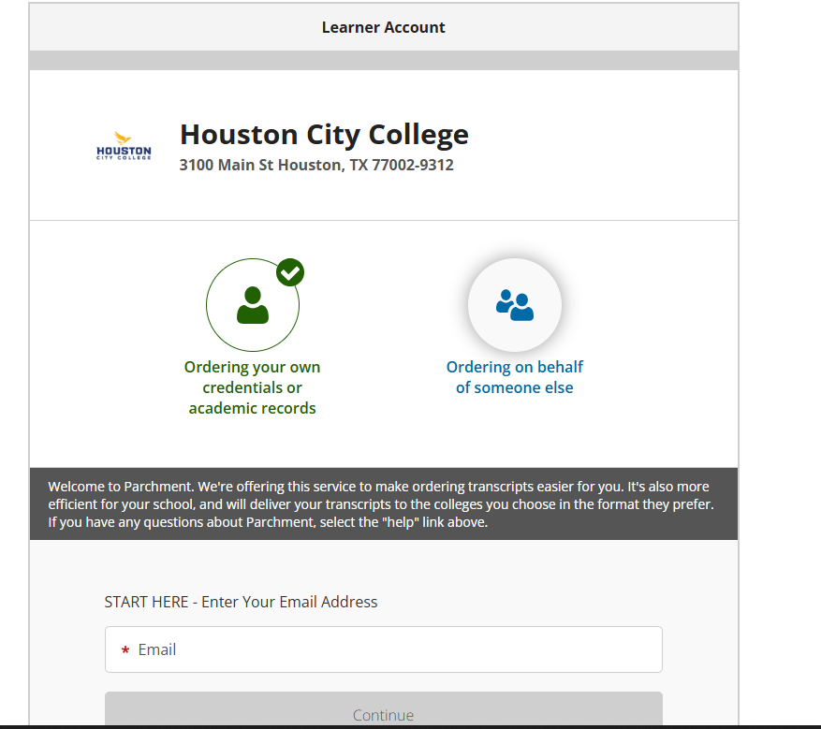
Requesting your UT OnRamps Transcript
If you are enrolled in a UT OnRamps course, you should have already accepted or declined your college credit. Make sure your grades appear on your grade report before ordering your transcript.
To request your transcript from UT OnRamps, login to the Online Transcript Order System.
- To order, in the Online Transcript Order System:
  - In Step 1, select “Send a transcript to me, a third party, or another educational institution using a different delivery method”.
  - In Step 3, select “Send to a third party or educational institution” and type in the information for your school.
- These electronic transcripts are sent the next business day after payment is received.

Submitting your SAT/ACT Score for TSI Exemption
If you are a Texas college applicant and did not submit SAT or ACT scores with your application, you may have a TSI hold on your account. You may qualify for an exemption if you meet the following benchmarks:
SAT EBRW Benchmark: 480 or higher
SAT MATH Benchmark: 530 or higher
ACT English: English & Reading combined score of 40 or higher
ACT Math: 22 or higher
If you met these scores, you will need to send your official scores to your school directly from College Board and/or ACT. NEITHER DR. WILLIAMS NOR YOUR COUNSELOR SENDS YOUR TEST SCORES TO YOUR SCHOOL.

Submitting your TSI Score
If you took the TSI and need to send your score to your school, you can do that through the ACCUPLACER student portal.
To send your TSIA scores, you will need to log into the ACCUPLACER Student Portal which can be accessed here.
You will need your TSDS Number. It is located at the top left corner of your transcript. Enter this number in the Student ID/Supplemental Student ID field.
In the Student Institution field, please select Fort Bend ISD.
See the screenshot below:
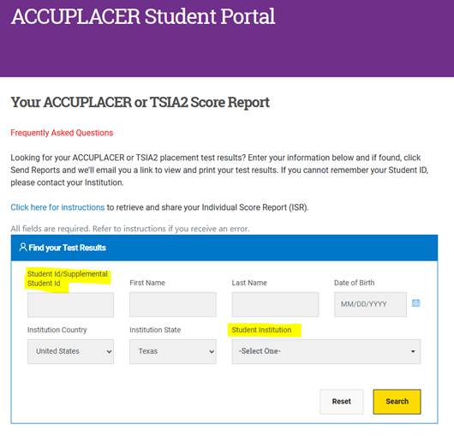
Once you submit the form, your test results will be sent to the email address you provided during your exam. Look for an email with the subject “Your ACCUPLACER Test Results.” If you don’t see it in your inbox, be sure to check your spam folder.
In the email, click “View ISR” to open your score report. You will see a list of all your test sessions, including the date and scores. If you have tested more than once, each session will appear separately. To view or print your full Individual Score Report (ISR), select “View Complete Report.”
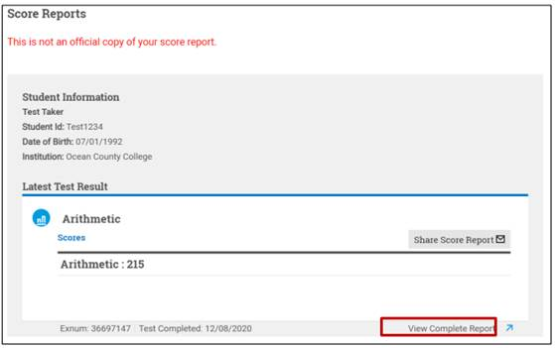
Your ISR will then be visible to save or print. Below is an example.
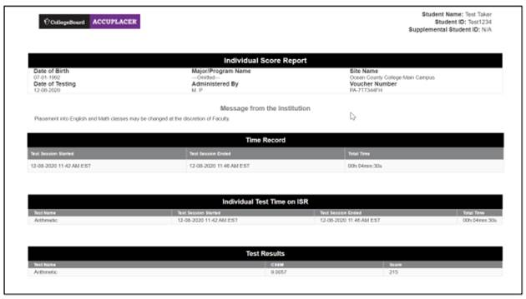
To send your scores to other institutions, select the “Share Score Report” button.
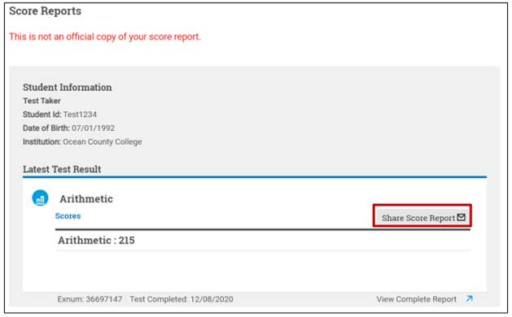
On the “Share Individual Score Report” window, use the Institutions dropdown menu to choose up to 3 institutions to send your scores to, then click the “Submit” button. If you wish to send your scores to additional institutions, complete the process again. Note: Not all institutions accept scores for tests taken at another school; only schools listed in the dropdown menu have agreed to receive scores through the Student Score Share function in the Student Portal.
